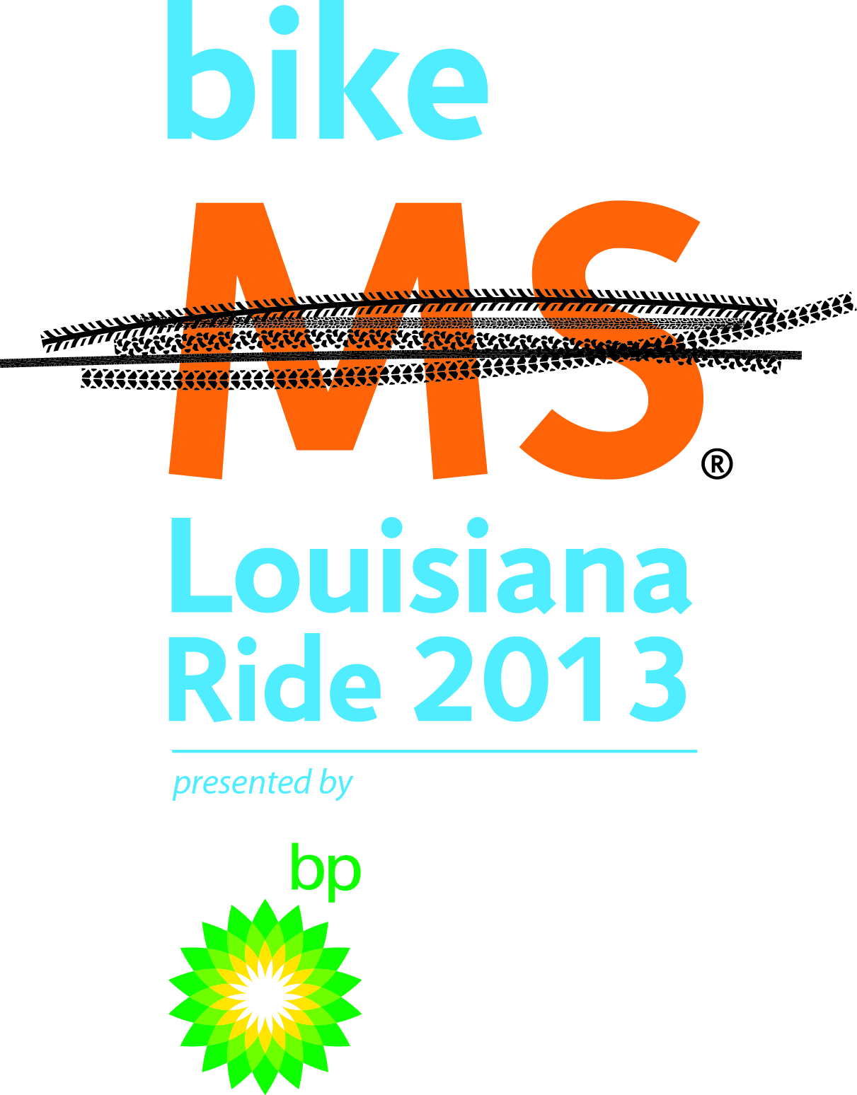
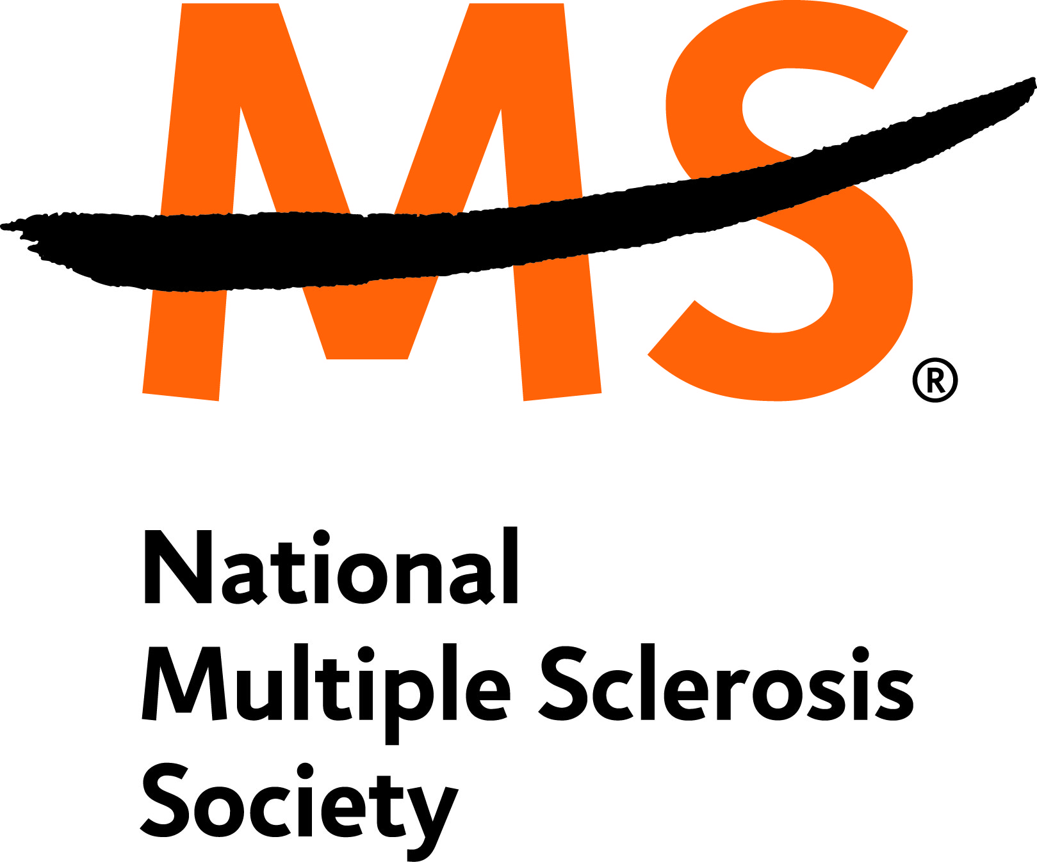
Date:

Receipent Name
Street Address
City, State Zip Code

Dear Recipient’s Name:

On October 5-6, 2013, I am participating in the Bike MS Louisiana bike tour as part of YOUR TEAM’S NAME. I am participating in the Ride to raise money to help fund research into the cause, treatment and cure for multiple sclerosis (MS) and provide services to the individuals affected by MS in Louisiana. I have challenged myself to ride 150 miles and raise $ GOAL

TOP 10 REASONS TO HELP ME RAISE MONEY FOR MS:

10. BECAUSE multiple sclerosis is a chronic, unpredictable neurological disease that affects the central nervous system, which is made up of the brain, spinal cord, and optic nerves. The progress, severity and specific symptoms of MS are unpredictable and vary from one person to another.

9. BECAUSE every week, 200 young adults in the United States learn that they have multiple sclerosis.

8. BECAUSE an MS diagnosis means never knowing how the disease will affect you. It could affect your ability to walk or talk, your vision, memory or cognitive skills. For some it will mean the end of their careers, for others everyday activities tasks such as caring for a child, making dinner or doing the laundry will become impossible.

7. BECAUSE MS strikes between the ages of 20 and 50, when people are just beginning their career, their marriage and their family.

6. BECAUSE for over 400,000 people in the United States, MS is a reality. In Louisiana, MS affects more than 4,000 people.

5. BECAUSE MS research gives us invaluable insight into the function of the immune and nervous systems and provides a window of treatment for MS and many other auto-immune diseases.

4. BECAUSE my goal is $ YOUR GOAL and I can only raise it with your help.

3. BECAUSE ALL donations (large and small) make a difference and are tax-deductible.

2. BECAUSE 150 miles is a long way to ride, but knowing I have your support will help me meet this challenge.

1. BECAUSE with continued research we can find a cure.

78 cents of each dollar donated funds research to find a cure, as well as providing programs and services for individuals and families affected by MS. Please join me in supporting the efforts of the National MS Society by making a tax-deductible donation on my behalf.

Please make checks payable to the National MS Society and mail directly to me. Be sure to write my name and
“Bike MS Louisiana” in the memo section.

Street Address
City, State Zip Code

As an alternative, you may donate online at the secure link below:
http://main.nationalmssociety.org/goto/YOURLINKHERE

Thanks for your support,
YOUR NAME, YOUR TEAM NAME

PHOTO
I RIDE
TO CREATE
A WORLD
FREE OF MS
TEAM WEBSITE ADDRESS
TEAM LOGO
PHOTO
PHOTO

